CARNIVAL COSTUMES

Which carnival costume do Mary and her friends wear?

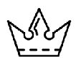
1. Mary has a long dress and a crown. Mary is a _________________________
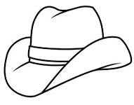
2. John has a brown hat and a lasso. John is a _____________________________
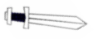
3. Rick has a helmet and a sword. Rick is a ______________________________
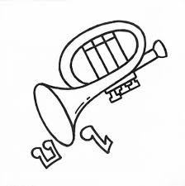
4. Alex has a trumpet . and a red nose. Alex is a ____________________________

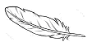
5. Tino is an animal. Tino is a _________________________________________

6. Adam has a hat with feathers and a sword. Adam is a ______________________________

7. Gabi has a white dress. Gabi is a ______________________________________________
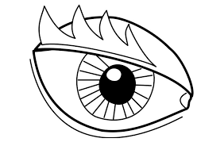
8. Mario has 1 eye. Mario is a __________________________________________
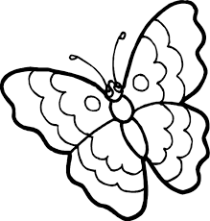
9. Anna has wings like a butterfly. Anna is a ________________________________
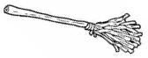
10. Clara has a broom and a black hat. Clara is a ________________________
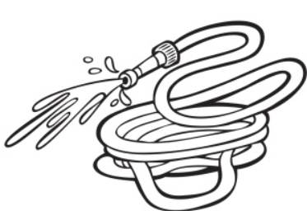
11. Mark has red clothes and a water hose. Mark is a _________________________
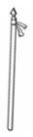
12. Frank has a lance and a hat with feathers. Frank is a ____________________________

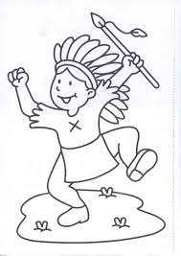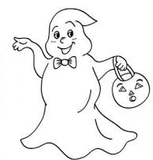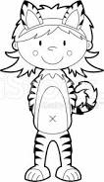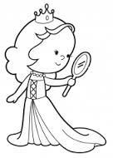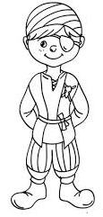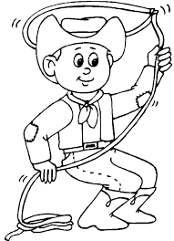

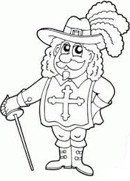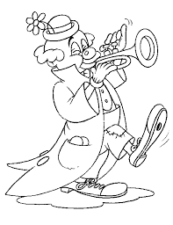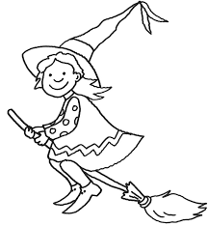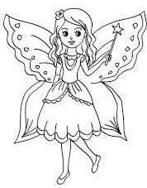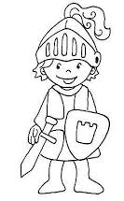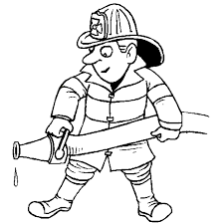

CARNIVAL COSTUMES

Which carnival costume do Mary and her friends wear?

1. Mary has a long dress and a crown. Mary is a _________________________
2. John has a brown hat and a lasso. John is a _____________________________
3. Rick has a helmet and a sword. Rick is a ______________________________
4. Alex has a trumpet . and a red nose. Alex is a ____________________________

5. Tino is an animal. Tino is a _________________________________________

6. Adam has a hat with feathers and a sword. Adam is a ______________________________

7. Gabi has a white dress. Gabi is a ______________________________________________
8. Mario has 1 eye. Mario is a __________________________________________
9. Anna has wings like a butterfly. Anna is a ________________________________
10. Clara has a broom and a black hat. Clara is a ________________________
11. Mark has red clothes and a water hose. Mark is a _________________________
12. Frank has a lance and a hat with feathers. Frank is a ____________________________

